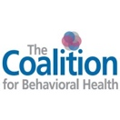
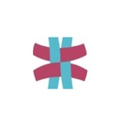
Regional Addiction Resource Center
Community Outreach Mini-Grant

The Regional Addiction Resource Center (RARC) focuses on outreach and prevention within the five boroughs of New York City. Each year we look to provide support regarding substance use awareness within our local counties.

The Regional Addiction Resource Center is looking to endorse:
- Substance use community outreach awareness projects that are found within vulnerable populations across the five boroughs.
- All vulnerable community undertakings will need a data-based justification as to why they are a focus population.
- Projects that support community engagement, respect, and partnerships.
- Projects to be funded between $1500 and $3000.

The Regional Addiction Resource Center will not support:
- Any project that offsets the cost of already existing programs and/or costs.
- A project that does not offer community outreach/partnerships.
- Projects that cannot produce some level of data to justify their intended population as vulnerable.

If your community fits the criteria, please complete the form below. The Regional Addiction Resource Center will review all requests on a rolling application process. If accepted, it is required that your program send an invoice for the accepted supported amount and a completed W-9 form.

If your project is approved, you will be required to complete a final report (see below). An additional prerequisite is to create a media campaign that supports showing the event was promoted by The Coalition for Behavioral Health’s Regional Addiction Resource Center thus containing the following logos:

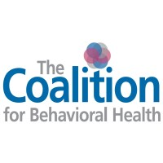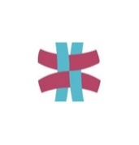

Some examples of media promotions are community posters, flyers, emails, palm cards and/or social media. Upon completion of the community event/partnership, a media image with the represented logos must be sent to dwolff@coalitionny.org

Community Outreach Mini-Grant Application Form

Agency name: ________________________________________________________________________
Agency Federal Tax ID: _________________________________________________________________
County: ______________________________________________________________________________
Contact: _____________________________________________________________________________
Contact e-mail: ________________________________________________________________________
Contact phone: ________________________________________________________________________
Event name: __________________________________________________________________________
Start date: ____________________________________________________________________________
End date: ____________________________________________________________________________
Funding amount requested: ______________________________________________________________
Community group targeted: ______________________________________________________________
Summary of data to justify specific population as vulnerable (Add additional sheets if necessary). _______________________________________________________________________________________________________________________________________________________________________________________________________________________________________________________________
Program description: (Add additional sheets if necessary). _______________________________________________________________________________________________________________________________________________________________________________________________________________________________________________________________
Expected number of individuals targeted at event/partnership: ___________________________________
Expected outcomes (Add additional sheets if necessary). __________________________________________________________________________________________________________________________________________________________________________

Signature: ____________________________________________________________________________

Date: ________________________________________________________________________________

*Submit completed application to dwolff@coalitionny.org

Community Outreach Mini-Grant Final Report

Agency name: ________________________________________________________________________
Event name: __________________________________________________________________________
Event cost: ___________________________________________________________________________
Event start date: _______________________________________________________________________
Event end date: ________________________________________________________________________
Number of individuals served by community event/partnership: ________________________________
Preparation hours for the community event/partnership: ________________________________________
Describe the community event/partnership. What was it? Where was it? Who was involved? (Add additional sheets if necessary). _______________________________________________________________________________________________________________________________________________________________________________________________________________________________________________________________
What were the community impacts of the event/partnership? What changes occurred? (Add additional sheets if necessary) _______________________________________________________________________________________________________________________________________________________________________________________________________________________________________________________________

Signature: ____________________________________________________________________________

Date: ________________________________________________________________________________

*Submit completed form with event media images to dwolff@coalitionny.org

